|  |  |  |  |  |  |  |
| --- | --- | --- | --- | --- | --- | --- |
| DISTRIBUTION : | Firm | To | Ref | Copies | 1st page | e-mail |
|  |  |  |  |  |  |  |
|  |  |  |  |  |  |  |
|  |  |  |  |  |  |  |
|  |  |  |  |  |  |  |
|  |  |  |  |  |  |  |

**How to generate Detailed Design**

**in enterprise architect**

OBJECT

This document describes how to install and configure Enterprise Architect - Detailed Design Generator tool.

|  |  |  |
| --- | --- | --- |
| STATUS: | For comments | ✓ |
|  | For application |  |

|  |  |  |
| --- | --- | --- |
| Established by | Reviewed by | Approved by |
| Name: Puscasu David  Date: 26.05.2023  Visa: | Name:  Date:  Visa: | Name:  Date:  Visa: |

# EVOLUTION OF THE DOCUMENT

|  |  |  |  |  |
| --- | --- | --- | --- | --- |
| **Issue** | **Date** | **Author** | **Rev.** | **Motive and nature of the modifications** |
| ?????? | 26.05.2023 | Puscasu David | 1.1 | First Revision |
|  |  |  |  |  |
|  |  |  |  |  |
|  |  |  |  |  |
|  |  |  |  |  |
|  |  |  |  |  |

**CONTENTS**

EVOLUTION OF THE DOCUMENT 2

1. RELEVANT DOCUMENTS 4

2. GLOSSARY OF TERMS / EXPRESSIONS 4

3. PREREQUISITES 4

4. HOW REPORTS ARE GENERATED 5

# RELEVANT DOCUMENTS

|  |  |  |
| --- | --- | --- |
| **N°** | **Title** | **Reference** |
|  | CommentsRules_for_EnterpriseArchitect_DetailedDesignGenerator.docx | [CommentsRulesDocument](CommentsRules_for_EnterpriseArchitect_DetailedDesignGenerator.docx) |

# GLOSSARY OF TERMS / EXPRESSIONS

|  |  |
| --- | --- |
| ***Term*** | ***Definition*** |
|  |  |
|  |  |

# PREREQUISITES

First of all, for this tool to work, it is absolutely necessary to have the **Enterprise Architect software installed**.

It is absolutely necessary to map the S: drive.

Before running the tool make sure you have added the necessary data to the **yaml configuration file**.

If, however, it is necessary to install certain tools, the tools used, in particular, by the generator are **Doxygen** and **yFlowGen** tools.

# HOW REPORTS ARE GENERATED

The tool needed to generate reports is called **EA_DetailedDesignGenerator.exe**. This tool must have beside it **Tools** folder and config file yaml (**Detailed_Design_Generator_Config_File.yaml**).

To generate reports:

1. You need to be in Executables folder. You must find there two folders called **Tools** and **result_yFlowGen** and 2 files, one called **Detailed_Design_Generator_Config_File.yaml** which will be referred as config file and script file: **EA_DetailedDesignGenerator.exe** which is executable script file.
2. Modify (using a text editor, ex: Notepad++) config file accord your paths and your configuration (**Detailed_Design_Generator_Config_File.yaml** file). This tool can also work in S: drive. So, if you need to run this tool from here, modify only component name in YAML config file.

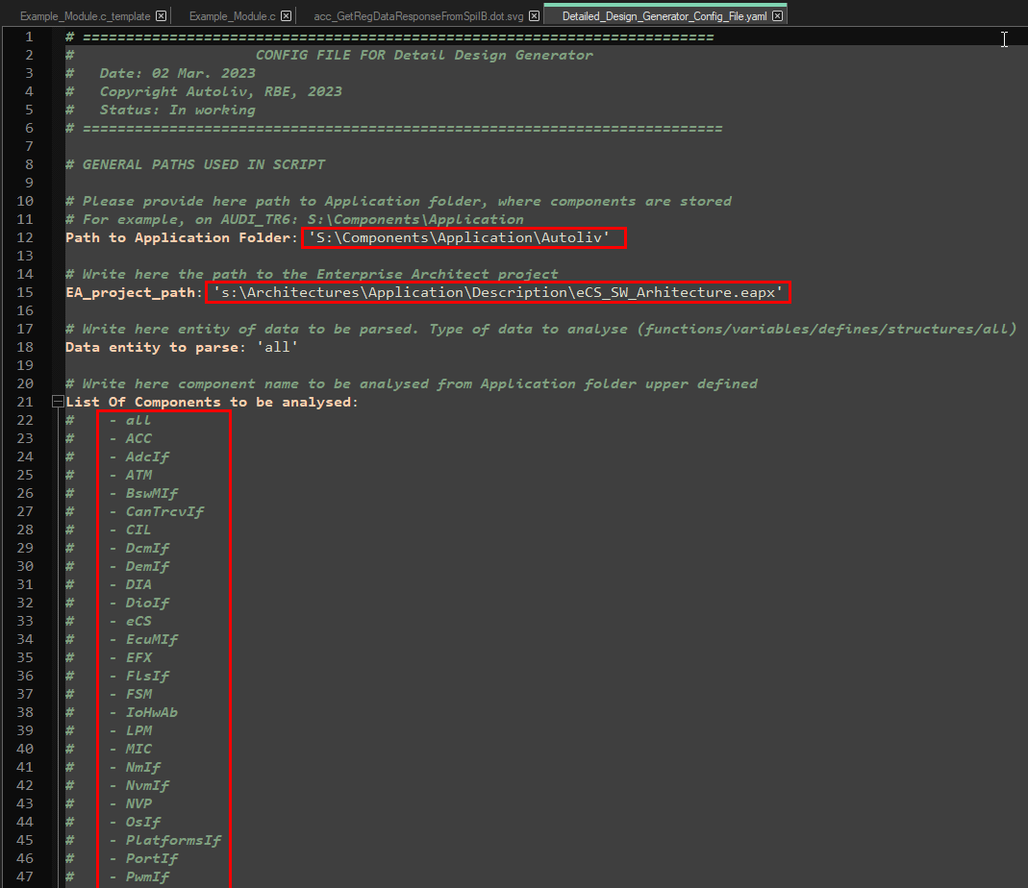

1. Before running this tool, it is necessary to have an Enterprise Architect license assigned. You can open Enterprise Architect in a project to generate the Detailed Design documentation there. If you **have not opened Enterprise Architect**, the **eapx project specified in the yaml configuration file** will be opened automatically in the background.
2. Run .exe file: **EA_DetailedDesignGenerator.exe**

* Prior to running the script on a certain software component, it is **mandatory** to verify that all the comments added in code is according to [**Comments Rules for Enterprise Architect – Detailed Design Generator**](CommentsRules_for_EnterpriseArchitect_DetailedDesignGenerator.docx) document. Otherwise, there is a possibility that the Enterprise Architect Model generated does not contain accurate data.